http://laptops.eng.uci.edu/software-installation/miktex?tmpl=%2Fsystem%2Fapp%2Ftemplates%2Fprint%2F&showPrintDialog=1:

About MikTex and How to Install it with Success (eng.uci.edu)

Introduction
Tex and LaTex are markup languages used for typesetting. Most commonly, they are used to publish computational material in scientific journals when there are complex mathematical equations. Typical word processing software such as MS Word cannot format equations properly. Furthermore, journals usually have a specific format their writers need to follow, and input files are an easy way to guarantee uniformity. Input files also provide a way to organize bibliographic entries.
- Occasionally, students need to use LaTex.
- If you ever plan on submitting research to a scientific journal, there's a strong likelihood you'll have to know how to Tex.
- MikTex is the Windows implementation of Tex & LaTex.
- Tex & LaTeX run on Unix & Linux and you can find tutorials online to get them installed and working on Ubuntu (for example).
- Most of our students use Windows so I'll provide you with some basic steps to get MikTex working in Windows.

Contents
Introduction 1
Required Components 2
Installation 2
Test your installation 3
Online Tutorial 4
Additional Information 4

Required Components
In order MikTex to run smoothly, you need to have all the following components:
1) You need a postscript interpreter (GhostScript)
- GPL GhostScript
2) You need a postscript viewer, GhostVIew
- GSview
3) You need a PDF viewer
- Adobe Reader
4) You need a Tex & LaTex compiler
- MiKTeX
5) You need an editing environment. There are many choices including:
  - WinEdt
  - TexMaker
  - TexStudio
  - TeXnicCenter

Installation
IMPORTANT:
I have better luck getting MikTex to work when I install the software to a directory (aka "a folder") with no spaces in its path. In other words, you'll notice "Program Files" has a space between those two words. When you compile tex files using C:\Program Files\MikTex, you'll get hiccups because of the space.
AND You must follow the steps below in the order given:
1) Start by creating a folder called "Apps' on your C: drive.
- This is the folder will install all your MikTex components.
- The full path name you will install to: C:\Apps\
- The path I use in the computer labs is: D:\Apps
2) Install GhostScript to a directory with no space:
- C:\Apps\ghostscript
3) Install GhostView to a directory with no spaces:
- C:\Apps\GhostView
4) Install Adobe Acrobat, default is okay:
- C:\Program Files\Adobe
- Sometimes it doesn't matter if the Adobe Reader path has a space, but if the PDF viewer does not work within your tex editor, reinstall it to C:\Apps.
5) Download and install MikTex full installer:
- MiKTeX 2.9 Net Installer
  - Again, Install to a directory with NO spaces in it's path:
  - C:\Apps\MikTex
- For the labs, I prefer to use the network full installer because I have a good reliable network connection. When I use the "basic" installer I have to go back and choose which components to install and it's easy to get confused. If you are concerned with disk space, use the basic installer and only install what you need.
6) Install Editing Software:
- Here are some choices:
  - WinEdt
  - TexMaker
  - TexStudio
  - TeXnicCenter
Again, for each of these, I prefer to install to C:\Apps.

Test your installation
For more help try these links:
- For Practice and Getting Started
- How to Use LaTex
- Standard TeX Directory Structure (TDS)
Steps to compile your Tex or LaTeX file:
- Typically, you would copy and paste the text into your favorite editor, such as WinEdt.
- You would save the file.
- Then, there are buttons you click to compile the document.
- You might see some errors generated. For your first time, just keep clicking the compile button until the process is complete.
- Next, you would see a .dvi version.
- You can then click the "dvi2pdf" button to generate a .pdf version.
- You can then click the "dvi2ps" button to generate a postscript (.ps) version.

Online Tutorial
LaTeX Tutorial 01 your first "hello world" document
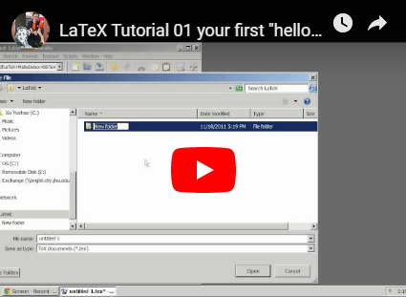

Additional Information
- http://theseekersquill.wordpress.com/2010/03/07/install-configure-latex/
- TeXnicCenter Required Components
- A review of LaTex editors for Windows

